**INTRODUCTION**

In today’s digital age, managing student data shouldn’t feel like a chore. Educational institutions deal with a massive amount of information—from enrolment records to attendance tracking—and relying on outdated, paper-based systems only makes things slower, more error-prone, and unnecessarily complicated. That’s where the *Student Management System*comes in. Designed to streamline and automate these processes, this platform provides a simple, efficient, and secure way for both administrators and students to manage academic records with ease.

At its core, this system is built on a powerful database management system (DBMS) using MongoDB, ensuring fast access, secure authentication, and well-organized record-keeping. Developed with Node.js, Express.js, and EJS, it’s designed to handle real-time updates and seamless backend processing, making student data management smoother than ever. With a user-friendly interface, administrators can track attendance, assign roll numbers, update student details, and manage profiles effortlessly—all in just a few clicks.

The goal of this project is simple: to modernize student management for BCA Department while making the experience more intuitive and stress-free. Features like automated roll number assignment, attendance tracking, profile updates, and OTP-based password recovery ensure that both administrators and students can navigate the system effortlessly. By reducing paperwork and eliminating inefficiencies, this project takes a step toward a smarter, more organized, and technology-driven approach to education.

**PROFILE OF THE PROBLEM**

INTRODUCTION:

Managing student records and attendance manually is error-prone and inefficient. The “STUDENT MANAGEMENT SYSTEM” streamlines these tasks, providing a centralized platform for the BCA department. Unlike the official college website, this system focuses solely on student record management.

Built with Node.js, Express.js, MongoDB, and EJS, it ensures secure, real-time data handling with features like automated roll number assignment, attendance tracking, and profile management. By eliminating paperwork and reducing errors, it enhances efficiency, accuracy, and accessibility in student administration.

PURPOSE:

This project aims to modernize student management by offering an automated and user-friendly system. It enables:

1. Secure Student Enrolments & Authentication
2. Attendance Tracking & Short Attendance Alerts
3. Automated Roll Number Assignment
4. Profile Management & Image Uploads
5. OTP-Based Password Recovery

By replacing manual processes with automation, the system saves time, reduces administrative workload, and ensures better data organization.

SCOPE:

The system is highly flexible and future-proof, with possibilities for expansion:

* **Performance Analytics** – Gain insights into student progress and academic trends
* **Automated Notifications** – Keep students informed about attendance status, exam schedules, and important deadlines.
* **Mobile App Integration** – Provide easy access to student records and updates.

Built with long-term efficiency in mind, this system not only eliminates paperwork but also improves accuracy, enhances accessibility, and streamlines student management. It’s a modern, scalable solution designed to meet the evolving needs of the BCA department.

**FEASIBILITY ANALYSIS**

FEASIBILITY:

Feasibility analysis is a test of the system proposal according to its workability, impact on organization, ability to meet user needs and effective use of resources. The objective of the feasibility analysis is not to solve the problem but to acquire sense of its scope. An initial investigation culminates in proposal that determines whether an alternative system is feasible. A proposal summarizing the thinking of the analyst is presented to the user for review.

Steps in feasibility analysis:

* Form a project team and appoint a project leader.
* Prepare system flowcharts.
* Enumerate potential proposed systems.
* Define and identify characteristics of proposed system.
* Determine and evaluate performance and cost effectiveness of each proposed system.
* Weight system performance and cost data.
* Select the best proposed system.
* Prepare and report final project directive to management.

TYPES OF FEASIBILITY:

For approving the development of proposed system, three major aspects in the feasibility analysis are considered. These are:

* Economic Feasibility
* Technical Feasibility
* Operational Feasibility

ECONOMIC FEASIBILITY:

The Cost-Benefit Analysis determines whether the project's benefits outweigh the costs. The transition from a manual system to a digital platform significantly reduces administrative workload, paperwork, and errors, leading to long-term savings. Since this project minimizes human effort, it proves to be economically viable and cost-effective.

TECHNICAL FEASIBILITY:

This aspect assesses whether the existing hardware and software can support the system. Key considerations include:

* Ability to handle student records and transactions efficiently.
* Fast response time for data retrieval and updates.
* Scalability to accommodate future enhancements.

The system is built using Node.js, Express.js, MongoDB, and EJS, making it lightweight, efficient, and compatible with modern infrastructure. As no significant hardware upgrades are required, the system is technically feasible.

OPERATIONAL FEASIBILITY:

Adopting a new digital system requires users to adapt to changes. However, since the system reduces workload, improves accessibility, and enhances efficiency, administrators are highly receptive to it. Training sessions for faculty and staff ensure a smooth transition, making the system operationally feasible and user-friendly.

CONCLUSION:

The “STUDENT MANAGEMENT SYSTEM” is economically, technically, and operationally feasible, offering a cost-effective, efficient, and user-friendly solution for student record management. Its implementation will enhance accuracy, reduce workload, and streamline administrative processes, making it a valuable asset for the BCA department.

**SOFTWARE SYSTEM ANALYSIS**

Nowadays, quality has become an important factor to be considered while developing software. This is due to the fact that users are interested in quality software, which is according to their requirements and is delivered within a specified time. Creating high-quality software isn't just about writing code—it’s about building a system that meets user needs, runs smoothly, and stands the test of time. A well-designed platform should be reliable, efficient, easy to maintain, and adaptable across different devices and environments. To ensure this, several key factors come into play, from performance and security to flexibility and ease of use.

RELIABILITY:

A system should function smoothly and accurately under all conditions, ensuring users can rely on it without disruptions. Reliability comes from a combination of error prevention, real-time fault detection, and swift issue resolution, allowing the system to operate efficiently. By optimizing these aspects while staying within time and resource constraints, the system maintains high performance, stability, and user trust.

AVAILABILITY:

The system is designed to be accessible 24/7, ensuring uninterrupted service for students and administrators. Downtime is minimized and occurs only during scheduled maintenance, backups, or updates to improve performance and security.

MAINTAINABILITY:

A well-designed system should be easy to update, expand, and troubleshoot without causing disruptions. By leveraging modern technologies and comprehensive documentation, such as Software Requirements Specification (SRS) and design blueprints, the system remains scalable, flexible, and future-proof. This ensures that new features, performance improvements, and bug fixes can be implemented effortlessly, keeping the system relevant and efficient over time.

PORTABILITY:

The system should function seamlessly across different hardware and software environments with little to no modifications. This flexibility ensures smooth deployment on various devices, operating systems, and web browsers without compatibility issues.

EFFICIENCY:

An efficient system optimizes resource usage to deliver fast performance without overloading servers. It ensures quick data retrieval, smooth processing, and minimal lag, making student record management more seamless and responsive.

CONCLUSION:

By focusing on reliability, availability, maintainability, portability, and efficiency, the Student Management System ensures a high-quality, scalable, and future-proof solution for student record management. These factors make it a robust and efficient tool for the BCA department, enhancing productivity and user experience.

**DATA FLOW-DIAGRAMS:**

A Data Flow Diagram (DFD) visually represents how data moves through a system. It helps in understanding system requirements, identifying key processes, and defining data interactions. By breaking down complex operations into simplified graphical components, a DFD serves as the foundation for designing and structuring the system efficiently.

In the “STUDENT MANAGEMENT SYSTEM”, the DFD outlines how student data, attendance records, and authentication processes flow between users, the database, and administrative functions. It ensures a clear and modular approach to system development.

DFD Symbols & Their Roles in the Project -

**Process (Function):**

A process represents an action or function performed within the system. In this project, key processes include:

* **Student Registration & Login** – Authenticating users and storing credentials
* **Admin Panel Operations** – Managing student records, attendance, and profile updates.
* **Roll Number Assignment** – Generating roll numbers for students based on their semester.
* **Attendance Tracking** – Marking short attendance and notifying students.

**Symbol:** Represented by a circle (bubble) with the process name inside.

**Source or Destination of Data (External Entities):**

These are users or external systems that interact with the website by inputting data or receiving information. In this system:

* **Students** provide data during registration, view their attendance, and update profiles.
* **Admins** manage student records, assign roll numbers, and track attendance.

**Symbol**: Represented by rectangles indicating external sources interacting with the system.

**Data Flow (Movement of Data):**

* Data flows between processes, external entities, and the database. Examples include:
* Student submitting login credentials → Authentication process
* Admin updating student details → Database storage
* Attendance status update → Student Portal Notification

**Symbol:** Represented by arrows showing data movement.

**Data Storage (Database & Files):**

A data store holds student information, attendance records, and authentication credentials. In this project, the database includes:

* **Student Records** – Name, email, semester, roll number, attendance, profile picture.
* **Authentication Data** – Encrypted passwords and OTP verification records.
* **Attendance Logs** – Marking students as “cut” if they have short attendance.

**Symbol:** Represented by two parallel lines, with arrows indicating read/write operations.

**Output (Reports & Notifications):**

The system generates outputs such as:

* **Attendance Warnings** – Displaying messages on the student portal for short attendance.
* **Admin Reports** – Showing sorted student data based on semester and attendance.
* **Roll Number Assignments** – Auto-generated and displayed on the student’s profile.

**Symbol:** Represented by a paper-like symbol for printed reports or a screen display icon for on-screen messages.

The DFD for the “STUDENT MANAGEMENT SYSTEM” illustrates how data flows seamlessly between students, administrators, and the database. It ensures that all functionalities, from authentication to attendance tracking, are properly structured and managed. By visualizing

system interactions, the DFD helps streamline development, improve efficiency, and enhance user experience.

**0-Level DFD:**

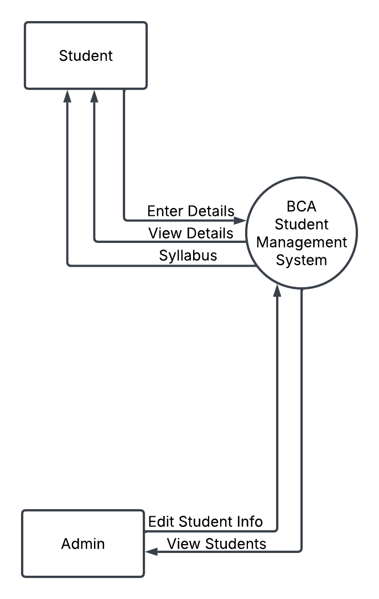

**1st – Level DFD:**

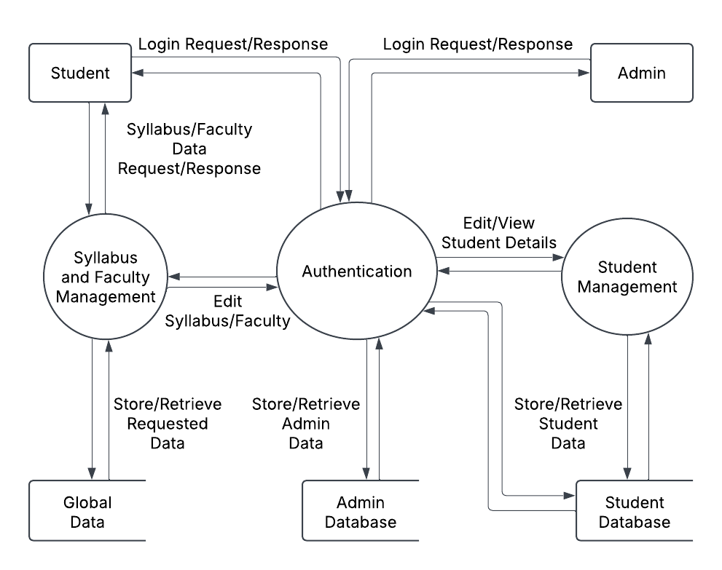

**ER-DIAGRAMS**

The Entity-Relationship (ER) Diagram provides a visual representation of how data is structured and related within the “STUDENT MANAGEMENT SYSTEM”. It helps in understanding the relationships between different entities, such as students, administrators, attendance records, syllabus details, and notifications.

The ER diagram consists of the following key components:

ATTRIBUTE:

Attributes define the specific details related to an entity. Each entity in the system contains multiple attributes that store relevant information.

ENTITIES:

Entities represent real-world objects or concepts within the system. In this project, the primary entities include:

* **Student** – Stores student details such as name, email, roll number, and semester.
* **Admin** – Represents the system administrators managing student data.
* **Attendance** – Tracks student attendance records.
* **Syllabus** – Contains syllabus and faculty information for students.

RELATIONSHIPS:

Relationships define how different entities interact with one another. The key relationships in this project include:

**One-to-Many**:

* An **Admin** can manage multiple **Students**.
* A **Student** can receive multiple **Notifications**.
* An **Admin** can update multiple **Attendance** records.

**Many-to-Many**:

* Students can access multiple **Syllabus** records, and a syllabus can be linked to multiple students.

**Entity Relationship Diagram:**

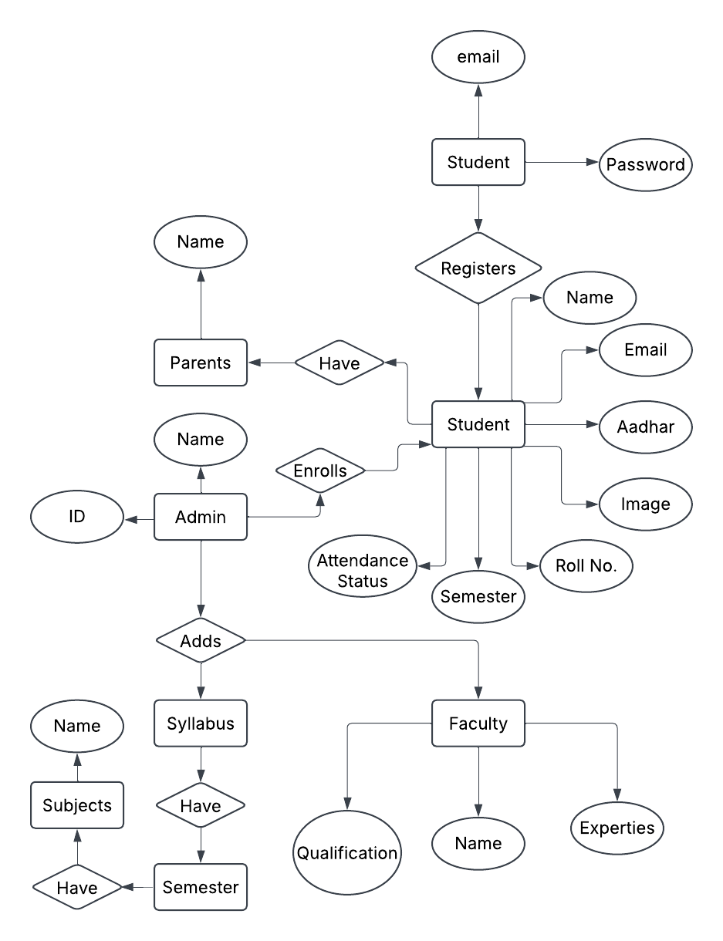

**SYSTEM DESIGN**

The “STUDENT MANAGEMENT SYSTEM” is designed to streamline student record management, attendance tracking, and administrative tasks within the BCA department. It provides a centralized platform for students and administrators, ensuring efficiency, accuracy, and easy access to information.

**Module Descriptions**

**1. User Authentication & Registration**

* Students can register using their email and create an account.
* Secure login system with password hashing.
* OTP-based email verification for password recovery.

**2. Student Portal**

* Students can view their profile, including name, roll number, email, semester, and attendance status.
* If a student is marked with short attendance, a warning notification is displayed.

**3. Admin Panel**

* **Dashboard:** To manage all student records.
* **Mark Short Attendance**: Admin can mark students with low attendance, which triggers a warning on the student portal.
* **Assign Roll Numbers**: Roll numbers are automatically assigned based on the year of admission and student’s name.
* **Edit Student Details**: Admin can modify student data (name, email, semester, etc.).
* **Delete Student**: Remove student records from the system.

**4. Attendance Management**

* Admin can track attendance records of students.
* Short attendance students are flagged and notified.

**5. Faculty & Syllabus Management**

* Faculty information is managed through the backend and displayed for students.
* Syllabus details are provided for each semester.

**6.** Notification System

* Automated warning messages for students with low attendance.

**System Architecture**

The system follows a client-server model with a MongoDB database, Node.js backend, and EJS for dynamic rendering. The architecture ensures:

* Secure authentication and data encryption.
* Real-time updates for student records.
* Scalability to support future enhancements.

**SCREEN-SHOTS**

**Home Page:**

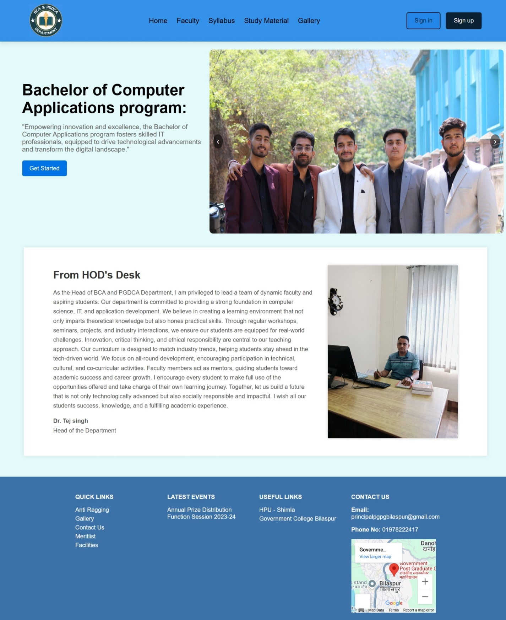

**Student Log-in:**

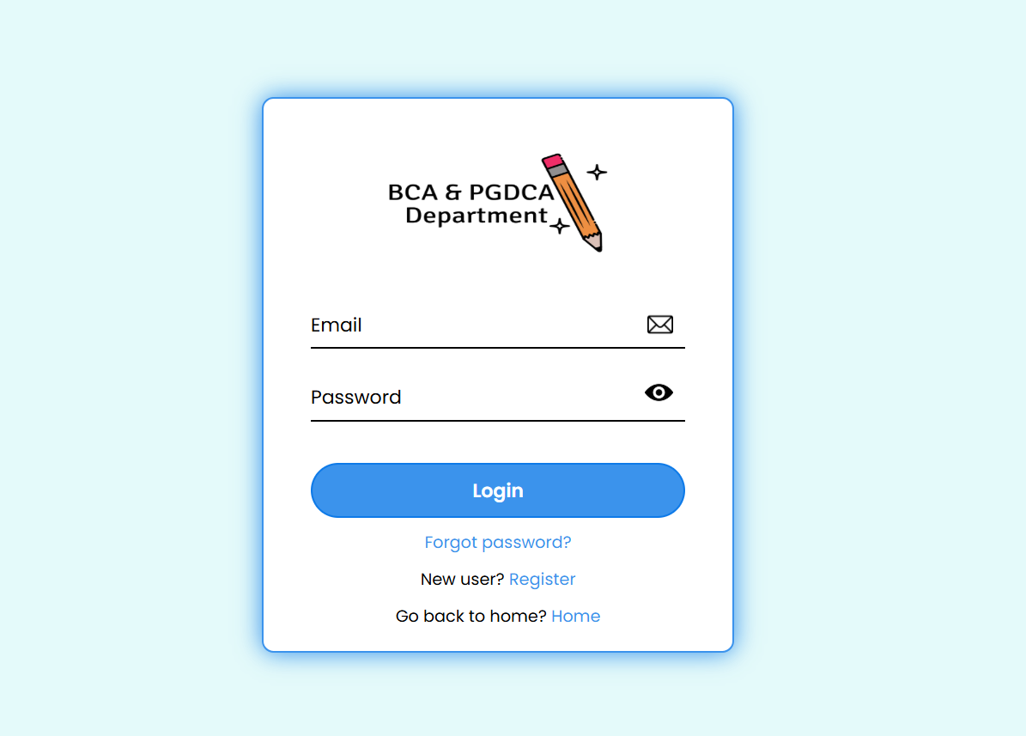

**Student Register:**

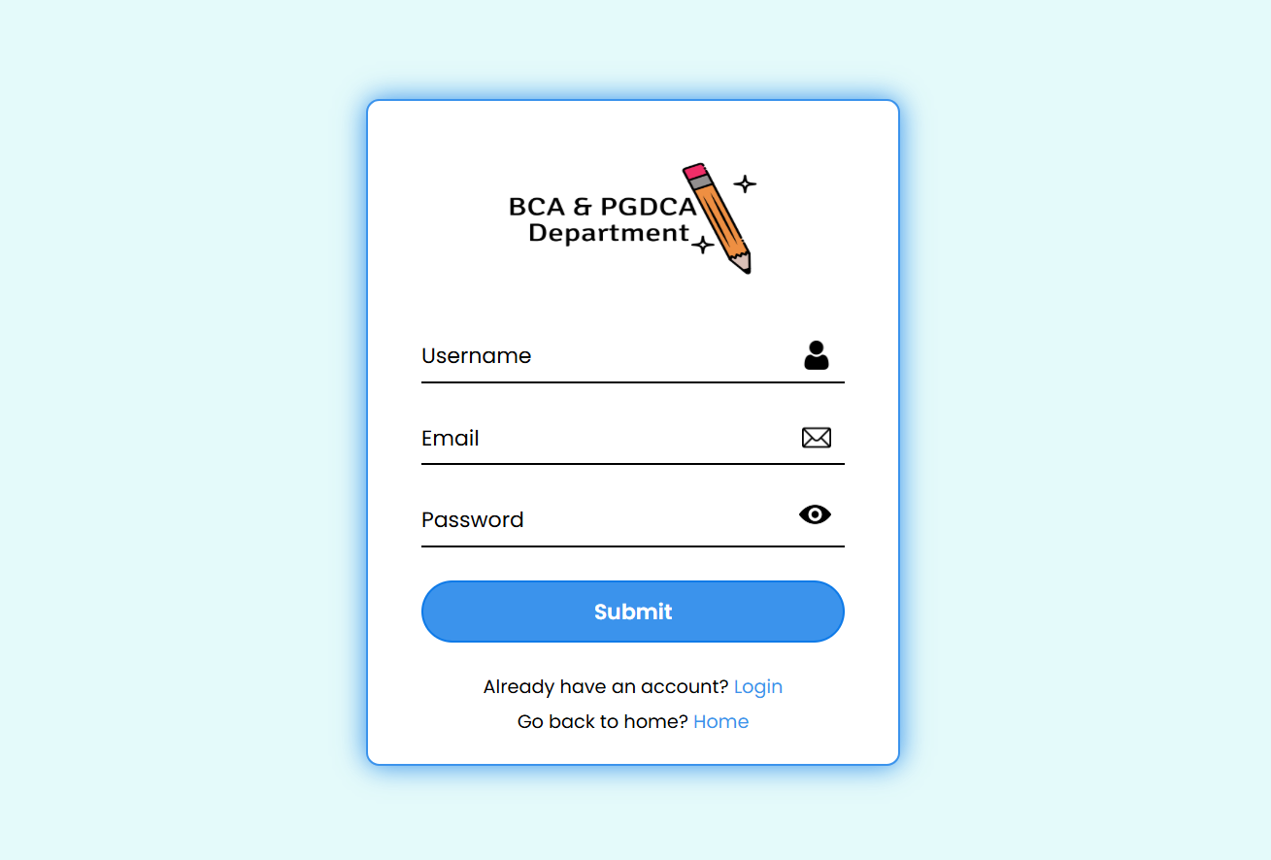

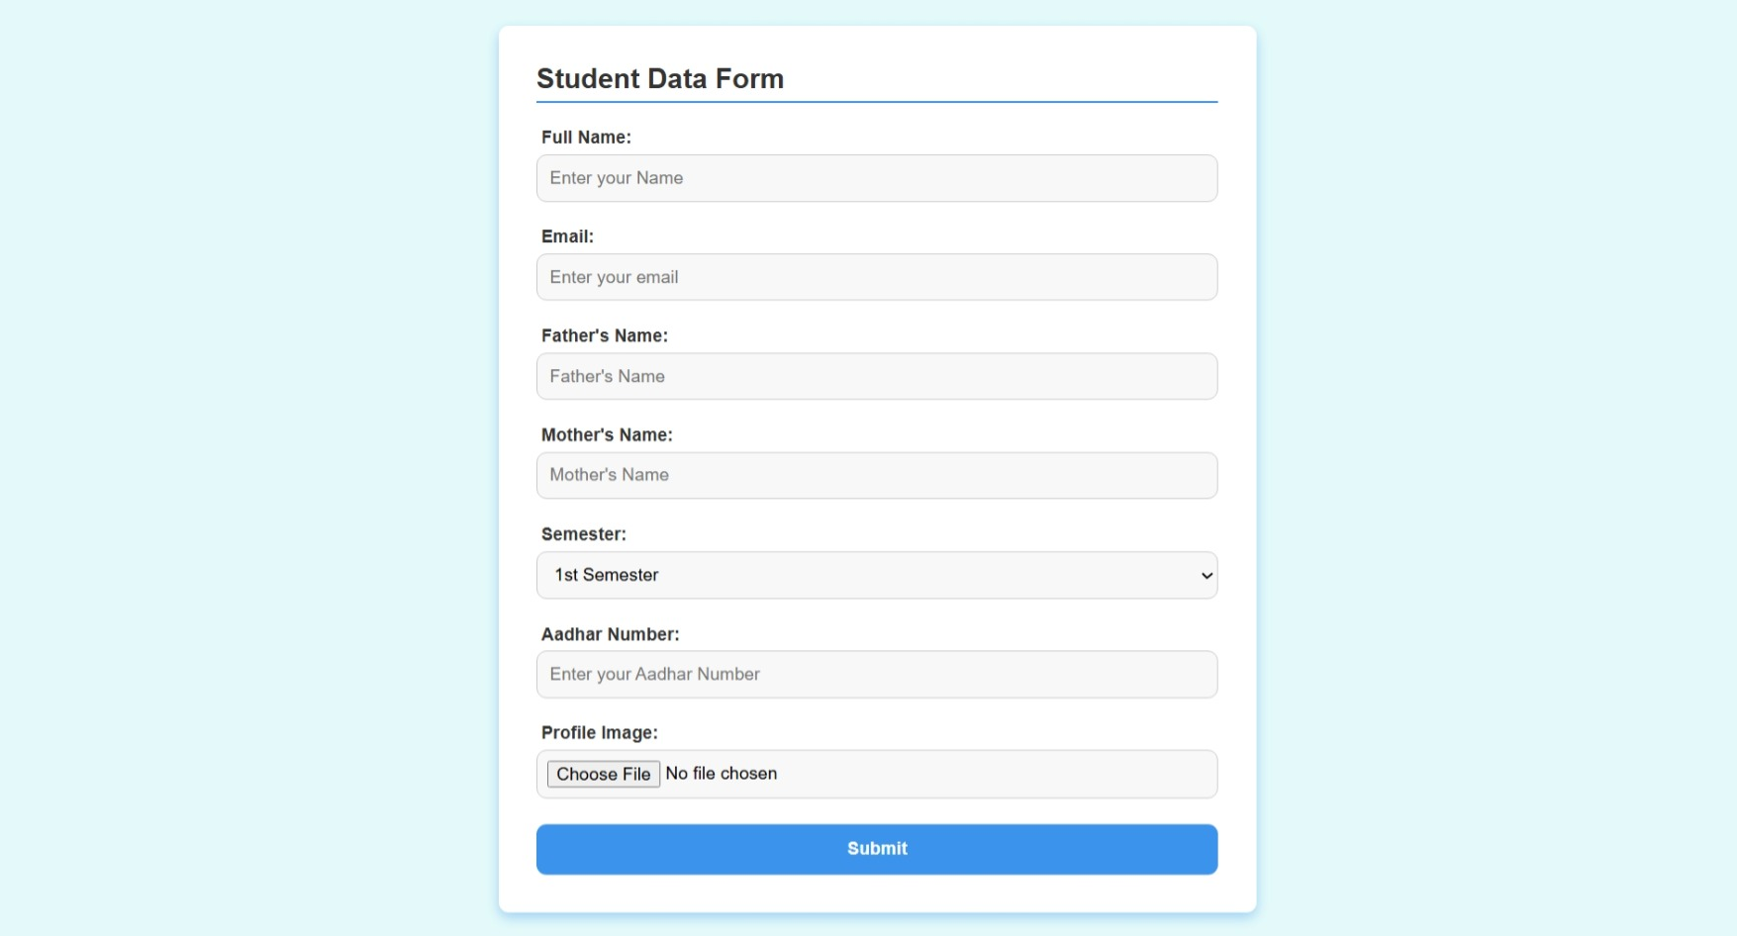

**Email Verification:**

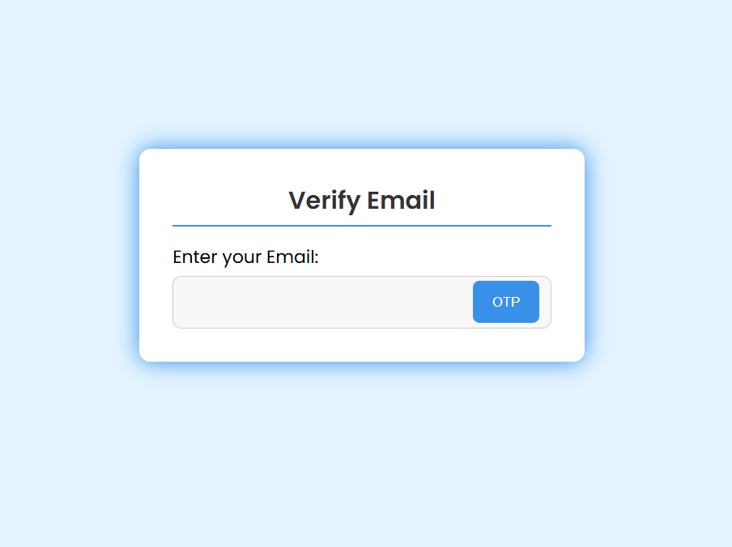

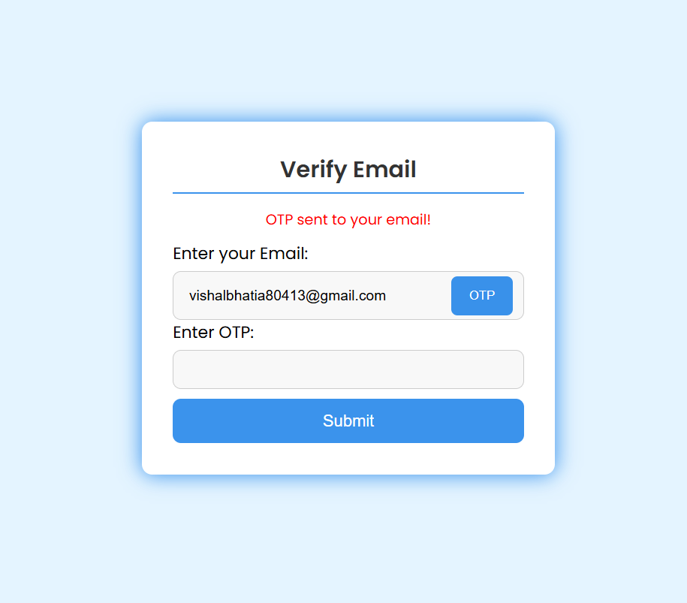

**Student Portal:**

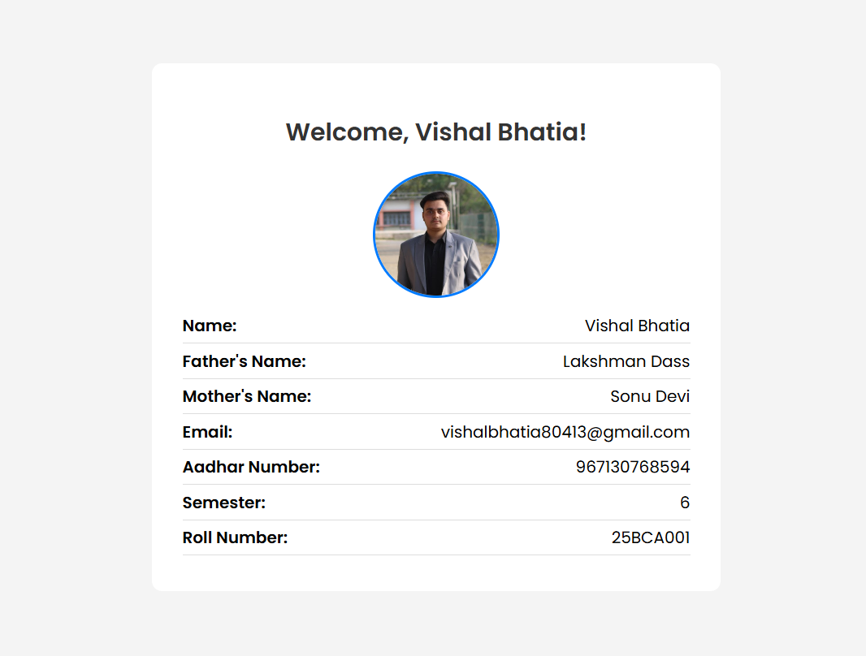

**Admin Panel:**

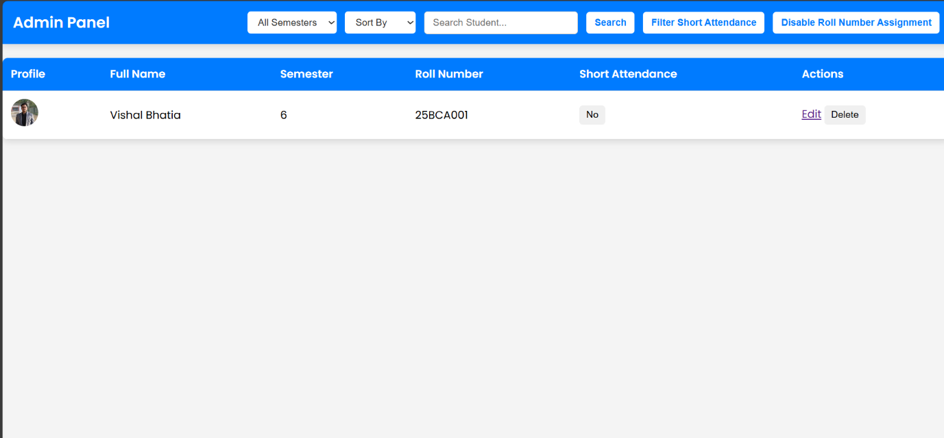

**Faculty & Department:**

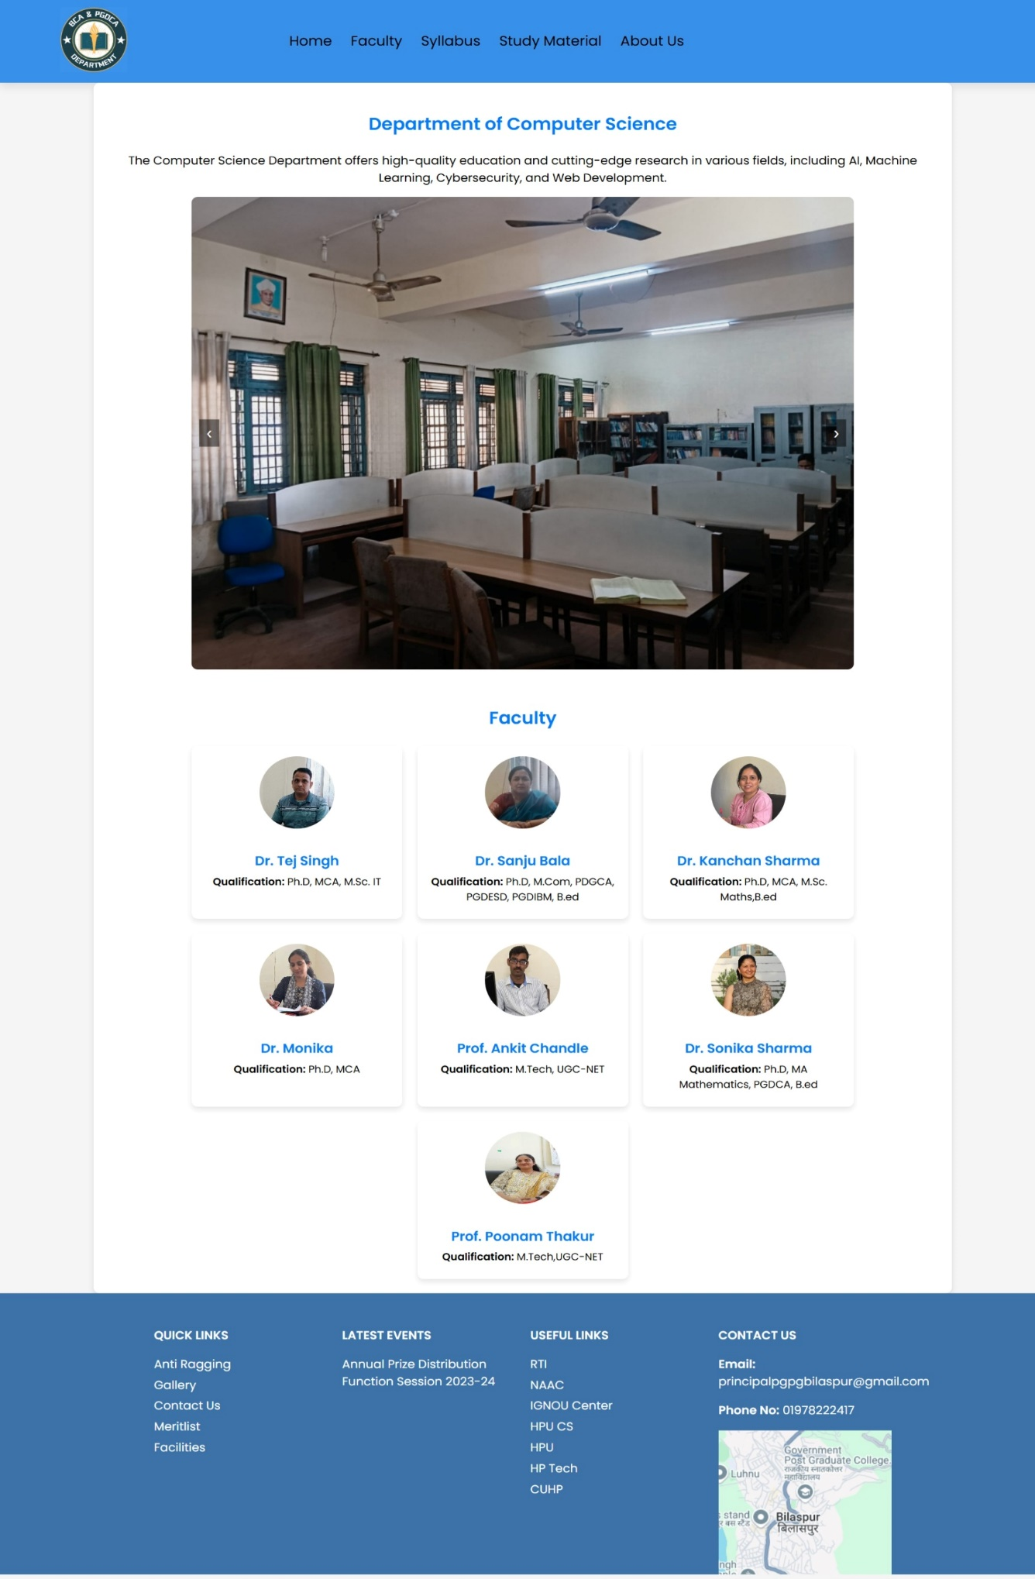

**Syllabus:**

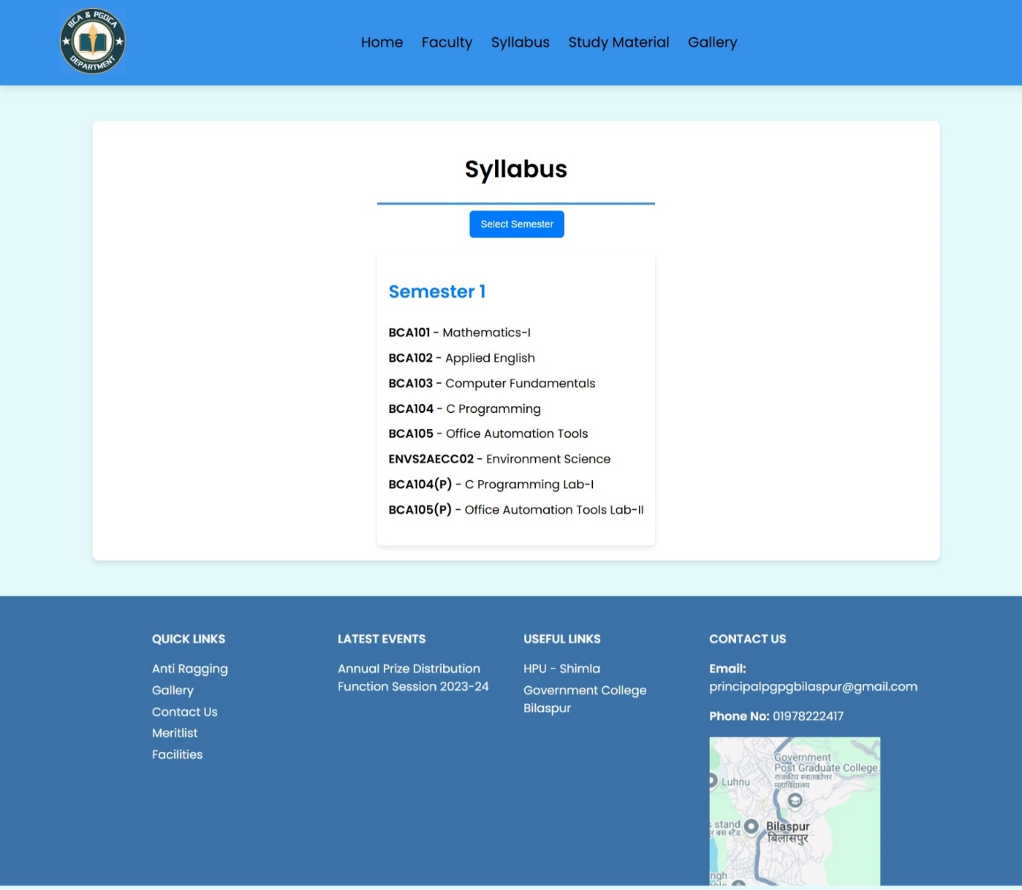

**Additional Learning Resources:**

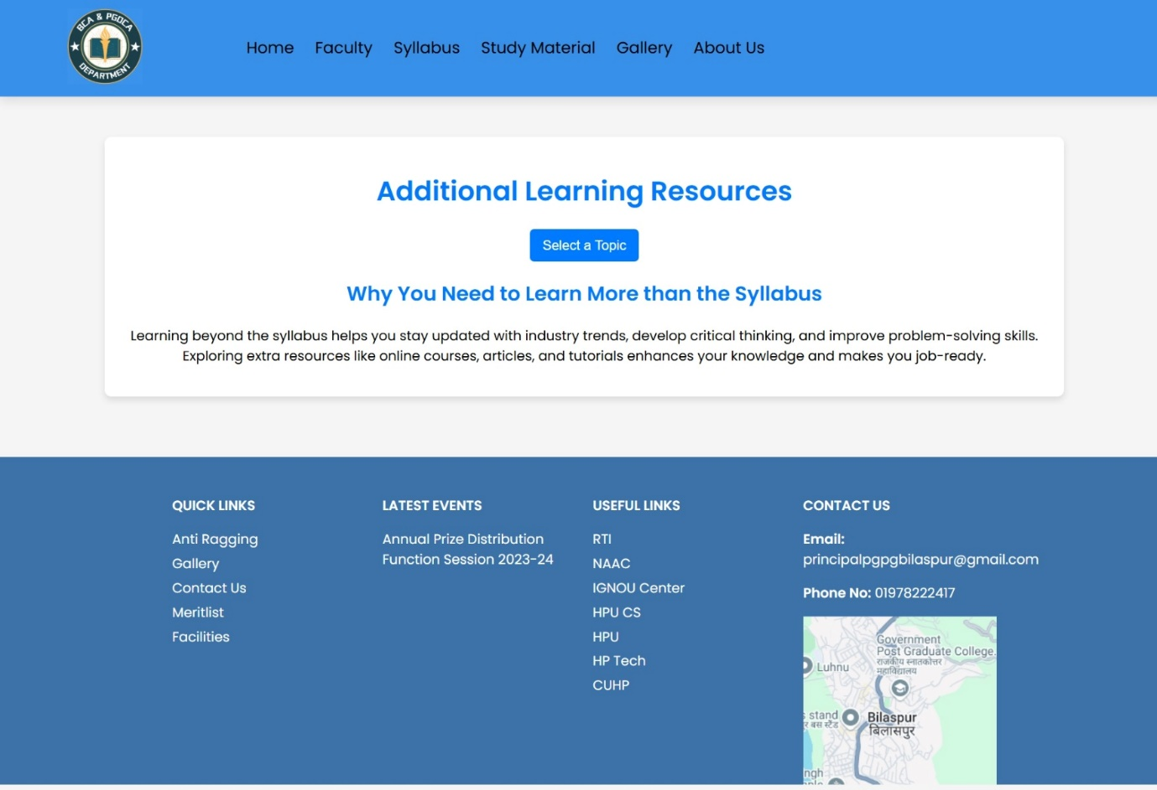

**DATABASE DESIGN**

The “STUDENT MANAGEMENT SYSTEM” uses MongoDB, a NoSQL database, to store student records, authentication details, administrative actions, and additional academic resources.

**1. Student Collection (students)**

Stores student details, academic records, and attendance status.

**Fields:**

* **_id** (Primary Key) – Unique identifier for each student.
* **fullName** (String) – Student’s full name.
* **email** (String, Unique) – Student’s email.
* **fathersName** (String) – Father’s name.
* **mothersName** (String) – Mother’s name.
* **aadharNumber** (String) – Aadhar identification number.
* **profileImageURL** (String) – Path to profile picture.
* **semester** (String) – Student’s current semester (1–6 or PGDCA).
* **rollNumber** (String, Unique) – Auto-assigned roll number based on admission year and name.
* **shortAttendance** (Boolean) – Flag for short attendance status.
* **createdAt** (Timestamp) – Record creation date.
* **updatedAt** (Timestamp) – Last modification date.

**2. Student Authentication Collection (studentRegs)**

Manages student login credentials.

**Fields:**

* **_id** (Primary Key) – Unique identifier for each student.
* **fullName** (String) – Student’s full name.
* **email** (String, Unique) – Used for login authentication.
* **salt** (String) – Random salt for password encryption.
* **password** (String, Hashed) – Securely stored password.

**3. Admin Collection (admins)**

Stores admin credentials and access details.

**Fields:**

* **_id** (Primary Key) – Unique identifier for each admin.
* **adminID** (String, Unique) – Admin’s login ID.
* **creator** (String) – Name of the person who created the admin account.
* **password** (String, Hashed) – Securely stored password.

**4. Admin Settings Collection (adminSettings)**

Stores system-wide settings.

**Fields:**

* **_id** (Primary Key) – Unique identifier.
* **rollNumberAssignment** (Boolean) – Flag for enabling/disabling roll number auto-assignment.

**5. OTP Collection (otp)**

Handles OTP-based password recovery.

**Fields:**

* **_id** (Primary Key) – Unique identifier for each OTP record.
* **email** (String) – Student’s email requesting OTP.
* **otp** (String) – Generated OTP code.
* **createdAt** (Timestamp, Auto-Expires in 5 minutes) – OTP expiration time.

**6. Faculty Data (Stored in globalData.js)**

Faculty details are not stored in MongoDB but are provided statically via globalData.js.

**Structure:**

* **name** (String) – Faculty member’s name.
* **qualification** (String) – Faculty’s degree.
* **expertise** (String) – Specialization.
* **image** (String) – Path to faculty image.

**7. Syllabus Data (Stored in globalData.js)**

Syllabus details are not stored in MongoDB but provided through the backend.

**Structure:**

Each semester has multiple subjects with a subject name and a subject code.

Example:

'1': [{ subject: 'Mathematics', code: 'BCA101' }, { subject: 'C Programming', code: 'BCA102' }]

'2': [{ subject: 'Data Structures', code: 'BCA201' }, { subject: 'DBMS', code: 'BCA202' }]

**8. Additional Knowledge Resources (Stored in globalData.js)**

Extra learning resources (Git, Linux, Docker, etc.) are not stored in MongoDB but provided through the backend.

**Structure:**

* **topic** (String) – Subject of the resource.
* **definition** (String) – Brief explanation.
* **link** (String) – YouTube/video link.
* **article** (String) – Article/documentation link.

**MongoDB Advantages in This Project:**

* **NoSQL Flexibility** – Easily adapts to changing student and admin requirements.
* **Scalability** – Can handle large amounts of student and attendance data.
* **Faster Querying** – Indexing ensures quick data retrieval.
* **Seamless Integration** – Works well with Node.js & Express.js.

**SYSTEM ANALYSIS**

Developing software comes with challenges and risks that need to be properly analysed and managed. The “STUDENT MANAGEMENT SYSTEM” is designed to streamline student records, attendance tracking, and administrative tasks within the BCA department. However, several risks and uncertainties could affect its development and implementation.

**Scope & Purpose of This Document**

This document outlines potential risks associated with the development and implementation of the “STUDENT MANAGEMENT SYSTEM”. It covers key project risks, technical risks, and challenges that may arise, along with strategies to manage them effectively.

**Overview of Major Risks**

**Project Risks & Scheduling Risks**

* The project timeline may extend due to factors such as academic workload, examinations, or delays in testing and debugging.
* Unexpected changes in project requirements from faculty or department heads could lead to rework, affecting deadlines.

**Personal Risks**

* Lack of proper communication between the development team and stakeholders could lead to misunderstandings about requirements.
* Individual responsibilities in the team need to be well-defined to ensure smooth project execution.

**Requirement Problems**

* If requirements are not clearly defined at the beginning, it may result in confusion during development.
* Changes in system requirements after development has begun could lead to inconsistencies in design and functionality.

**Other Risks**

* The project’s complexity, such as handling multiple roles (admin and students), may introduce unforeseen challenges.
* System security risks, such as unauthorized access, need to be managed effectively.

**Technical Risks**

**Frequent Requirement Changes**

* If the department requests frequent modifications (such as adding new features), it could lead to an unstable system design.
* Proper version control and modular coding practices are necessary to handle changes efficiently.

**Technology Selection Risks**

* The system is developed using Node.js, Express.js, MongoDB, and EJS, which are modern technologies. However, if these technologies become outdated or unsupported in the future, maintenance could become difficult.
* Ensuring that the system is built with scalability in mind will reduce long-term risks.

**Implementation Risks**

* As the system involves role-based access (students and admins), proper authentication and security measures need to be implemented to prevent unauthorized data modifications.
* Integrating **OTP-based authentication** for password recovery ensures secure user management, but improper handling could lead to security vulnerabilities.

**SYSTEM ENVIRONMENT**

**HARDWARE REQUIREMENTS**

* **Processor:** Intel i3 or higher (recommended)
* **RAM:** 4GB or above (recommended)
* **Storage:** Minimum 20GB free space (SSD recommended for better performance)
* **Display:** Any standard display with 1366x768 resolution or higher
* **Network:** Stable internet connection for online access

**SOFTWARE REQUIREMENTS**

* **Operating System:** Windows 10, macOS, or Linux (Ubuntu recommended)
* **Backend Framework:** Node.js with Express.js
* **Frontend:** HTML, CSS, JavaScript with EJS templating
* **Database:** MongoDB
* **Package Manager:** NPM (Node Package Manager)
* **Authentication & Security:** JSON Web Token (JWT) & bcrypt
* **Other Dependencies:** Multer for file uploads, Nodemailer for email-based OTP verification

**PROJECT TESTING**

**What is Testing?**

Testing is the process of evaluating a system to determine its reliability, functionality, and performance. In software development, testing ensures that the system meets its intended objectives and functions correctly under various conditions. It is conducted at different stages, from individual module testing to system-wide evaluation, to identify and resolve potential errors.

For the “STUDENT MANAGEMENT SYSTEM”, testing was performed at multiple checkpoints to verify the accuracy of student registration, attendance tracking, admin functionalities, and secure authentication. Each module was tested individually before integrating it into the complete system.

**Testing Techniques**

The following testing techniques were applied to ensure system stability and efficiency:

* **Black Box Testing** – Focuses on verifying outputs based on inputs without analysing internal code logic.
* **White Box Testing** – Examines internal structures, logic, and code pathways to ensure accuracy and efficiency.
* **Gray Box Testing** – A combination of black and white box testing, considering both functional and internal aspects of the system.

**Testing Types**

To ensure a fully functional and error-free system, different levels of testing were conducted:

* **Unit Testing** – Individual modules, such as student registration and OTP verification, were tested separately.
* **Integration Testing** – Modules were combined to test interactions between different system components, such as student authentication with attendance tracking.
* **System Testing (Functional Testing)** – The entire system was tested to ensure smooth operation and that all features worked as expected.
* **Acceptance Testing** – The system was evaluated in real-world scenarios to confirm that it met the department’s requirements and was user-friendly for both students and administrators.

**Black Box Testing**

Black box testing focuses on evaluating a system based on inputs and expected outputs without analysing the internal code structure. This technique is commonly used for functional testing, including unit, integration, system, and acceptance testing.

For the “STUDENT MANAGEMENT SYSTEM”, black box testing was applied to:

* **Student Registration & Login** – Ensuring valid credentials grant access while incorrect inputs are rejected.
* **Attendance Tracking** – Verifying that attendance marking functions correctly without exposing internal logic.
* **OTP-Based Verification** – Checking if OTPs are generated, sent, and validated properly.

While black box testing effectively detects missing functionalities, it does not guarantee that all internal pathways are covered.

**White Box Testing**

White box testing analyses the system’s internal structure and logic to create test cases. It requires programming knowledge to ensure that all code paths are executed correctly.

This testing was applied in:

* **Database Queries** – Ensuring correct data retrieval and storage for student profiles and attendance records.
* **Session Handling** – Validating secure authentication and preventing unauthorized access.
* **API Endpoints** – Checking response times and error handling mechanisms.

White box testing helps uncover potential vulnerabilities but may need updates if the internal structure changes.

**Gray Box Testing**

Gray box testing combines aspects of both black and white box testing. It requires partial knowledge of internal components while primarily treating the system as a black box.

For the “STUDENT MANAGEMENT SYSTEM”, gray box testing was used to:

* Simulate real-world interactions between students and admins.
* Ensure secure data flow from frontend to backend without exposing sensitive logic.
* Test system behaviours using architectural insights while treating it as a user-accessible system.

**Testing Categories**

Software testing ensures the system meets technical and business requirements while identifying potential issues before deployment. It provides an objective evaluation of software quality and performance, helping stakeholders understand system reliability and potential risks.

Testing can occur at different stages of development, but the majority of testing is performed after coding is complete to ensure the system functions correctly before deployment.

**Unit Testing**

Unit testing verifies individual components of the system in isolation. In this project, unit testing was performed on:

* **User Authentication** – Ensuring login and session management function properly.
* **Database Operations** – Testing CRUD operations for storing and retrieving student data.
* **OTP Verification** – Checking OTP generation and validation for password recovery.

Each unit was tested separately to ensure accuracy before integrating them into the system.

**Integration Testing**

This testing phase ensures that different modules interact correctly. It focused on:

* **Admin Panel & Student Database** – Verifying that roll numbers and attendance updates reflect correctly in the database.
* **Frontend & Backend Communication** – Ensuring user actions (like login, profile updates) correctly modify the database.
* **Email OTP System** – Checking OTP delivery and verification with user authentication.

Integration testing helped identify and resolve communication gaps between system components.

**System Testing (Functional Testing)**

System testing evaluated the entire application as a whole to check compliance with requirements. Since it follows a black-box testing approach, no internal code knowledge was required. This phase tested:

* **User Navigation & UI Experience** – Ensuring all pages and features are accessible.
* **Role-Based Access** – Verifying that students and admins only access their respective portals.
* **Error Handling & Validation** – Checking system responses to invalid inputs, missing data, and failed logins.

**Acceptance Testing**

Acceptance testing determines whether the system meets user expectations before final deployment. In this project, it was conducted by testing:

* **Admin Features** – Ensuring attendance tracking, roll number assignment, and student record management function as required.
* **Student Portal** – Checking whether students can access their records, update details, and receive notifications correctly.
* **Security & Authentication** – Validating secure login, session handling, and OTP verification.

This phase ensured the system is ready for deployment and meets the operational requirements of administrators and students.

**PROJECT IMPLEMENTATION**

Successful implementation is a crucial phase in the software development life cycle. It involves deploying the system, ensuring a smooth transition from the old system, and making sure all features function as intended. The implementation process for this project included software installation, user training, and testing to verify system reliability. A live demonstration was conducted, allowing administrators and students to familiarize themselves with the system and clarify any doubts before full deployment.

**Approach Followed**

The top-down approach was followed to implement this project. Since the system consists of multiple modules, implementing them in a modular fashion ensures better scalability and maintainability.

**Top-Down Implementation Approach**

In a top-down approach, the core functionalities are implemented first, followed by dependent modules. The project implementation started with the Admin Panel, which serves as the central management module. After setting up administrative features such as student record management, roll number assignment, and attendance tracking, other modules were gradually added, including:

* **Student Portal** – To allow students to access their records and view attendance status.
* **Authentication & OTP Verification** – To ensure secure login and password recovery.
* **Faculty & Syllabus Management** – To provide relevant academic resources to students.

Each module was tested independently before integrating them into the system.

**Interdependency Between Modules**

The modules in the system are interconnected and rely on shared data:

* **Admin Panel** is the core module, as all student records are managed from here.
* **Student Portal** depends on the database managed by the admin for profile details and attendance updates.
* **OTP-based password recovery** is linked to the authentication system, ensuring secure access.
* **Faculty & Syllabus Info** is provided to students but managed from the backend.

Since data flows between different modules, the correct execution of one module affects the others.

**Post-Implementation Review**

Once the system was deployed, a review was conducted to assess whether it met user expectations. The system's performance, usability, and reliability were evaluated based on predefined criteria. Feedback from administrators and students was collected to identify potential improvements.

Post-implementation review helped in:

* Identifying areas for optimization and bug fixes.
* Ensuring the system functions as expected under real-world conditions.
* Collecting user suggestions for future enhancements.

**MAINTENANCE**

The maintenance phase of software development ensures that the system remains functional, efficient, and up-to-date. This includes bug fixes, performance optimizations, and incorporating new requirements as needed. If users request modifications or additional features in the future, they will be implemented as part of the maintenance process.

Currently, all the requirements specified in the System Requirement Specification (SRS) document have been successfully fulfilled, and the system is functioning as expected. No critical errors or logical bugs have been detected.

However, if new requirements arise, such as additional modules, improved security measures, or enhanced features, the system is designed to accommodate upgrades with minimal disruption. Regular monitoring and user feedback will help identify potential improvements, ensuring long-term reliability and scalability.

**PROJECT LEGACY**

**Current Status:**

The project is fully functional and ready for implementation. Developing this system has been a valuable experience, allowing for hands-on exposure to problem-solving and software development. The core objectives of the project have been successfully achieved, ensuring:

1. **Fast and efficient data access**
2. **User-friendly interface** for both students and administrators
3. **Easy search and retrieval** of student records and attendance
4. **Minimal errors** through automation and validation
5. **Time-saving processes** compared to manual record-keeping
6. **Graphical User Interface (GUI)** for intuitive navigation

**Remaining Areas of Concern:**

While the current system meets all basic requirements, future enhancements could include:

* Additional functionalities such as automated performance tracking and detailed analytics
* Enabling the system to run on a distributed network for broader accessibility
* A student report module for generating progress reports and detailed insights
* Integration with mobile applications for better accessibility and notifications

The project is designed with scalability in mind, allowing future updates to enhance efficiency and usability based on evolving requirements.

**CONCLUSION**

The “**Student Management System”** project has been successfully developed and documented, incorporating key principles from software engineering, database management, and system design. Throughout the project, we leveraged various resources to ensure the system's efficiency, reliability, and user-friendliness.

Key resources used in the project include:

* **Data Flow Diagrams (DFD):** Referenced from *System Analysis and Design* books.
* **Entity-Relationship (ER) Diagrams:** Adapted from *Database Management Systems* books.
* **Software Development Technologies:**
  + **Frontend:** HTML, CSS, JavaScript
  + **Backend:** Node.js with Express.js
  + **Database:** MongoDB
* **Testing & Debugging:** Various debugging tools and browser developer tools were used to ensure the system’s functionality.

Additionally, the guidance and mentorship of **Prof. Tej Singh** played a crucial role in shaping the project, helping us understand key concepts and improve our implementation.

This project not only strengthened our technical knowledge but also enhanced our problem-solving and teamwork skills. Future improvements can include additional features like an advanced analytics dashboard, automation tools, and AI-driven functionalities to enhance the system further.

With this, we conclude our project, marking it as a valuable learning experience that aligns with real-world application development practices.